Honors Earth Science: Mid-Term Study Guide
- What direction to lines of latitude run and what direction do they measure? What about lines of longitude?
- What would cause cities at the same elevation and latitude to have different yearly average temperature ranges?
- How was Earth’s original atmosphere formed?
- What is the order of Earth’s Eras from oldest to youngest?
- What is the difference in weather on the windward side versus the leeward side of a mountain?
- Know where each air mass forms and the characteristics of them. mP, mT, cP, cT
- What is the primary geologic process occurring along the San Andreas Fault?
- Describe the temperature changes of Earth’s atmospheric layers as we increase altitude starting at Earth’s surface.
- In what layer is our weather located? What about the ozone layer?
- What causes the air along Earth’s surface to heat up and then start to rise?
- What is a hot spot? Where are the hotspots found around the world?
- What evidence do we have for previous life forms on Earth?
- Starting at the center, list and describe Earth’s layers.
- Write the phases of the moon and draw what the moon would look like in the sky for each of the 8 phases.
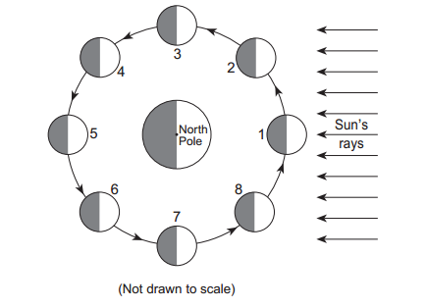
- What is the position of Earth, Moon, and the Sun during a Solar Eclipse? Lunar Eclipse?
- Why do we see different phases of the moon?
- What does the law of superposition tell us?
- Describe the motion of Earth around the sun. Is Earth always moving at the same speed?
The map below shows air pressures recorded in millibars (mb).
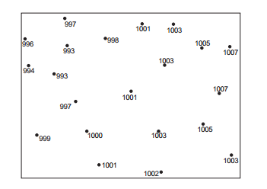
- Draw isobars for 996-mb, 1000-mb, and 1004-mb on the map above.
- What are the 3 types of plate boundaries? How do the plates move at each and what features do we find at each?
- What factors increase the destruction of an earthquake?
- What information can we learn from a graph showing the time differences between the seismic P-waves and the seismic S-waves as they travel through Earth?
- How do air masses move?
- What occurs when a fast-moving cold air mass moves into a region of warmer, moist air?
- What factors contribute to the formation of a hurricane?
- How is climate different from weather?
- What gases make up Earth’s atmosphere? Which is the most abundant?
- How could an abiotic factor impact the diversity of an ecosystem?
- How could the decline of one species’ population impact an entire community (the rest of the species in the food web)?
- What is an invasive species? Give some examples.
- How does clear cutting negatively impact the biodiversity of an area?
- Subsurface ocean currents continually circulate from the warm waters near the equator to the colder waters in other parts of the world. What is the main cause of these currents?
- Why is it important to conserve the biodiversity of Earth?
- What biome has a climate that is very cold and dry?
- What is a grassland with scattered trees called?
- What biome usually contains orchids, ferns, and other plants that live on the branches of trees?
- Why don’t many trees grow in a grassland?
- What biome has the greatest species diversity?

