Sidewalk Time Scale 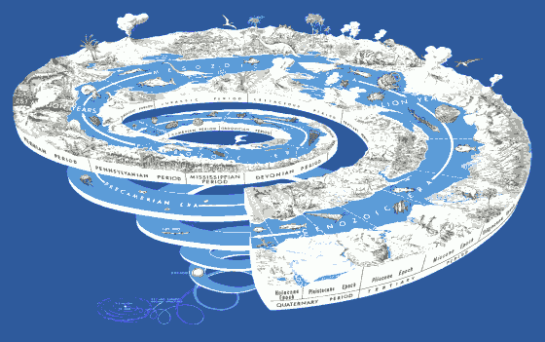

Instructions:
- Measure out 4.6 meters in a straight line. Each meter represents 1 billion years of earth’s history, each centimeter represents 10 million years, and each millimeter represents 1 million years.
- As a group, mark the beginning of each eon, era and period.

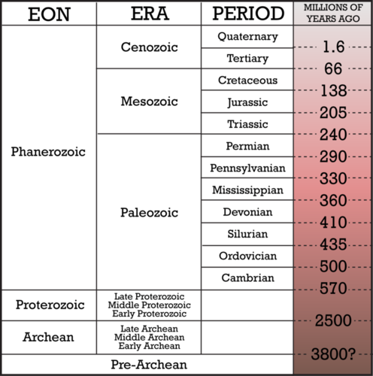
Precambrian Era

- Mark the following 27 events on your timeline:

- Formation of the Earth - 4.6 billion years ago
- Oldest Know Rock – 4.3 billion years
- First Single Celled Organism – 4 billion years
- Age of most continental crust – 3.7 billion years
- First viruses appear –3.5 billion years
- Cyanobacteria (photosynthetic) – 3 billion years
- Initial atmospheric oxygen – 2.4 billion years
- Evolution of eukaryotic (non-bacterial) life—1.8 billion years
- First Multi-Celled organisms – 700 million years
- Precambrian Extinction (70% wiped out) – 650 million years
- First Shellfish – 570 million years
- First Fish – 510 million years
- Appalachians form – 480 million years
- Plants move onto land – 450 million years
- First Amphibian – 375 million years
- First Reptile – 325 million years
- Permian-Triassic Extinction (99% wiped out) – 250 million years
- Mammals appear – 195 million years ago
- Opening of the Atlantic Ocean – 180 million years
- First Known Birds – 160 million years
- Rocky Mountains Form – 80 million years
- Extinction of Dinosaurs – 65 million years
- First Proto-humans appear – 35 million years
- Rise of The Himalayan Mountains – 20 million years
- Homo Sapiens!!! – 200,000 years
- Last Ice Age – 20,000 years
- Recorded Human history – 10, 000 years

- When finished, take a picture for your notes

