Unit 5 Study Guide: Population and Energy Use
- What three sources supply the majority of electric energy in the NC today?
- Compare and Contrast subsurface mining to surface mining
- How does population impact the amount of coal and natural gas on Earth?
- What energy resource is made possible by the volcanic activity?
- Describe the difference between nuclear fission and nuclear fusion?
- What classifies fuels as nonrenewable?
- What are the major disadvantages of using solar panels to generate electricity?
- What type of alternative energy source has the potential for visual and noise pollution?
- What are advantages of nuclear energy?
- What non-renewable fossil fuel is clean burning?
- How does the population of the United States and Canada compare to China and India?
- What is the current estimate of the size of the human population?
- How do we best describe the distribution of the human population worldwide?
- Describe each of the following Age-Structure Diagrams and list a country that each diagram describes

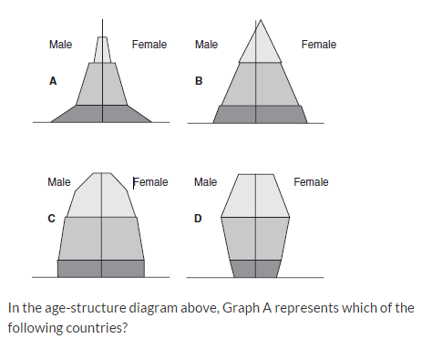
- What are the difficulties in defining the carrying capacity for the human population?
- How does a baby boom impact an age-structure diagram?
Use the graph below to answer the following question.
- Which of the following parts of this graph shows the exponential growth of the population?
- What does the horizontal line labeled x represent?
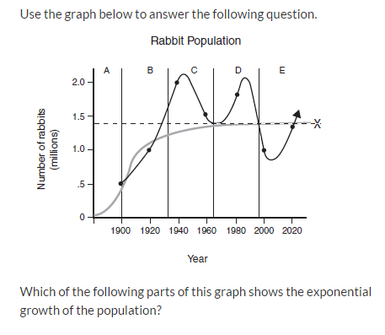
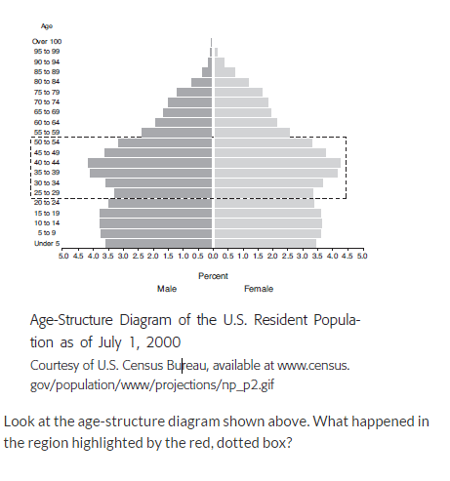
- When did the human population really begin to take off? Why?
- What is fracking?
  - What are some of the benefits of fracking?
  - What are some of the dangers of fracking?
- What is coal ash?
  - Summarize what happened at the Dan River coal ash spill.
- What are the benefits to nuclear power?
- What are the drawbacks to nuclear power?

